
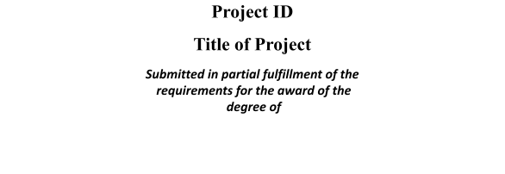


On

Session 2025-26 in
Computer Science and Engineering
By

Under the guidance of ---

SCHOOL OF COMPUTER SCIENCE AND ENGINEERING IILM UNIVERSITY, GREATER
NOIDA, INDIA

March, 2026



SCHOOL OF COMPUTER SCIENCE AND ENGINEERING IILM UNIVERSITY, GREATER NOIDA

Index page with the following items:

Section no. | Section | Page no.
1 | Introduction
2 | Problem Statement
3 | Objectives
4 | Methodology
5 | Tools & Technologies
6 | Expected Outcomes
7 | Applications
8 | Conclusion

Signature of Supervisor:

Date:

